

MS Word Training- Session-4: Part-1

Document Management
Version: 1.0
February 2009
Copyright Information:
This document is the sole property of AIG Inc. All rights reserved. No part of this document may be reproduced, stored in a retrieval system, translated, transcribed, or transmitted in any form or by any means, without the prior written permission of AIG Systems Solutions (AIGSS).
Document Information
S.No | Document Title | Base Version No. | Author | Contact Email ID | Date Of Release
1 | MS Word Training. Session 4 – Part 1 Document Management | 1.0 | Deepika Datta | deepika.datta@aig.com | February 2009
Revision History
S.No | Version No. | Date Of Release | Author (s) | Affected Section(s) | History of Changes | Approver

Table of Contents
1 Document Management 5
1.1 Creating a new document 5
1.2 Typing Text 5
1.2.1 Hard space 5
1.2.2 Click and Type 5
1.2.3 Correcting text 6
1.3 Saving a document 6
1.3.1 File names 7
1.3.2 Save as 7
1.3.3 Closing a file 7
1.4 Saving a document in another format 7
1.5 Opening a existing document 8
1.6 Exiting Word 8
1.7 Switching between open documents 9
1.7.1 Using the Window menu 9
1.7.2 Using the task bar 9
1.8 Inserting a second document into an open document 9
1.9 Using the help menu 9
1.9.1 The Word Help pane 9
2 Editing a Document 11
2.1 Moving around a document 11
2.1.1 Using the mouse on the vertical scroll bar 11
2.1.2 Using the keyboard 11
2.1.3 Using the menu 12
2.2 Selecting text 12
2.2.1 Selecting text with the mouse 12
2.2.2 Click and drag method 13
2.2.3 Extended selection 13
2.2.4 Canceling a selection 13
2.3 Copying text 13
2.4 Moving text 13
2.5 The Clipboard task pane 14
2.5.1 Copying or cutting multiple items 14
2.5.2 Pasting and deleting collected items 14
2.5.3 Paste options 14
2.6 Deleting text 14
2.7 Overtyping text 15
2.8 Undo and redo 15
2.9 Further editing techniques 15
2.9.1 Mouse techniques for copying and moving data 15
2.9.2 Copying data using the drag and drop method 15
2.9.3 Moving data using the drag and drop method 16
2.10 Find and replace 16
2.10.1 Finding a word 16
2.10.2 Replacing a Word 16
2.11 Spelling & Grammar Checking 17
2.11.1 Checking spelling and grammar as you go 17
2.11.2 Spell-checking a document 17
2.11.3 Spelling and Grammar dialog box options 18
2.11.4 Grammar checking 18
2.12 AutoCorrect 19
2.12.1 Creating an AutoCorrect entry 19
2.12.2 Adding an AutoCorrect entry during a spell check 19
2.12.3 Canceling an AutoCorrect entry 19
2.12.4 Deleting an AutoCorrect entry 19
2.13 AutoText 20
2.13.1 Creating an AutoText entry 20
2.13.2 Inserting an AutoText entry 20
2.13.3 Removing an AutoText entry 20
2.14 AutoFormat 20
2.14.1 AutoFormat as you type 20
2.14.2 Undoing automatic formatting 21
2.14.3 AutoFormat after you type 21
3 Viewing Modes 22
3.1 Different Viewing modes 22
3.1.1 Normal 22
3.1.2 Web layout 22
3.1.3 Print layout 22
3.1.4 Outline 22
3.1.5 Document map 22
3.2 Changing viewing mode 22
3.3 Other viewing controls 22
3.3.1 Full screen 22
3.3.2 Zoom 22
4 Printing 23
4.1 Print preview 23
4.2 Printing a document 23

Document Management

Creating a new document
On the File menu, click New, press Ctrl+N, or click on the New Blank Document button:
A new document is opened.
You can also use the New Document task pane to create a new document; simply click on Blank Document in the New category.

Typing Text
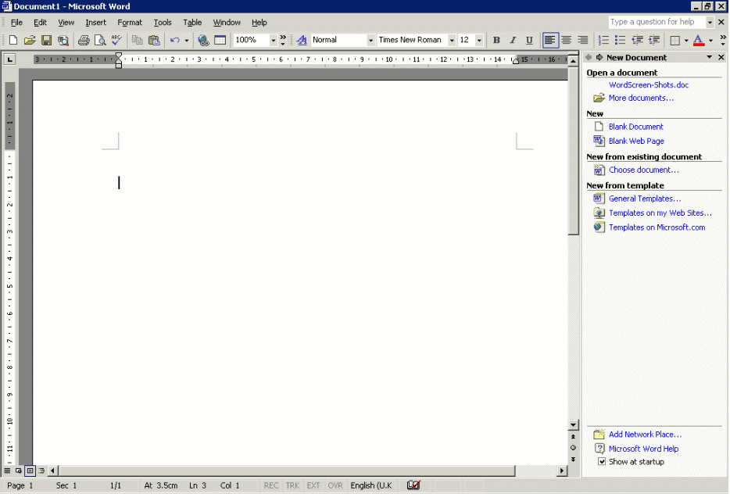
Every time Word is started, a new document is opened ready for you to enter text.
Insertion point
The insertion point flashing in the document area of the screen indicates where the text you type will appear. In Word 2003 you can move the insertion point to anywhere in your document by double-clicking at the point where you would like it to go.
Word, like most word processing packages, incorporates word-wrapping. This means that you should not press the Enter key ↵ at the end of each line. You only press Enter when you wish to end a paragraph or leave a blank line.

Hard space
Word thinks it can start a new line anywhere it finds a space or a hyphen. If you need to keep two words together on the same line (e.g., Mr()Smith, or 8()October) you can glue them together by using a hard space instead of an ordinary one. Hold both the Ctrl+Shift keys down when pressing the space bar, or hold both the Ctrl+Shift keys down when pressing the hyphen key to keep two hyphenated words together on the same line, e.g. Mr( )J( )Ellis(-)Brown.

Click and Type
Word has a new click and type feature that allows you quickly to insert text, graphics, tables, or other items in a blank area of a document. Click and type automatically applies the formatting necessary to position the item where you double-clicked. For example, to key in a centred heading, double-click in the middle of a blank page, and then key in your text.
To turn this feature on:
- From the Tools menus and select Options.
- Go to the Edit tab and ensure the Enable click and type option has a tick in it.
- Click on the box to enter a tick if necessary.
- Click on OK to close the dialog box and enable click and type.
You can insert items in most blank areas of a document. For example, you can insert a graphic below the end of the document; there's no need to press Enter to add blank lines. Or you can type text to the right of an existing paragraph without having to add a tab stop manually.
You can only use click and type when you are in Print Layout or Web Layout views, i.e., it is not available in the Normal view, Outline view, or Print Preview. (See page Error: Reference source not found for details of viewing modes.)
You cannot use click and type in the following areas:
- multiple columns
- bulleted and numbered lists
- next to floating objects (graphics or objects that have been inserted into the document)
- to the left or right of pictures with top and bottom text wrapping
- to the left or right of indents.
As you move the insertion pointer, the pointer shape indicates how Word will format your text. It will apply a left-, centre-, or right-aligned tab stop, a left indent, or left or right text wrapping, depending on where you click on the page. Watch the insertion point to see what type of formatting Word will apply. For example, if you point to the centre of the page, the pointer shape indicates that the item will be centred.

Correcting text
To correct simple typing mistakes either press the Backspace key ← to delete to the left of the insertion point or the Delete key to delete to the right of the insertion point.

Saving a document
As you type text, the work you do is held in the computer’s temporary memory. If the computer is switched off or develops a fault, you could lose work that is not saved. We can’t stress strongly enough:
Always save your work regularly.
By saving, you are ensuring that a permanent copy of your work is stored somewhere, whether on a networked drive or on a hard disk. Once the file has been saved, you can then continue working, making changes or adding more information as appropriate. Ideally, you should get into the habit of saving your work regularly – every 15 minutes or so.
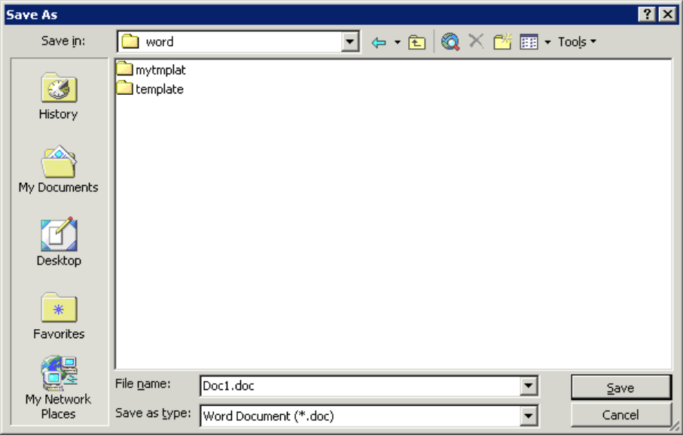
When saving a document for the first time, Word displays the Save As dialog box. You are prompted to name the file, and to select which folder and which drive you wish to put the file in.
Enter your file name here.
Select the appropriate drive here – click on the arrow for a list.
Select the folder here – double-click on the folder icon to open it.
- On the File menu, click Save, or press Ctrl+S.
- Choose the appropriate drive and folder, using the drop-down arrow in the Save in box. When you save a file for the first time, check where it is stored.
- Give your file a name. In the File name box, type a suitable name.
- Click Save.
Once the document has been saved, the file name will appear in the title bar at the top of the screen.
To re-save a document quickly with its existing name, location and file format, click the Save button on the Standard toolbar.

File names
A file name can contain up to 255 characters, including spaces, but not any of the following characters: \ / : * ? “ < > |.
Try to use meaningful names so that files can be more readily identified at a later date.
Word automatically adds the file extension .doc. It is important to retain this default as, by international convention, any file with the extension .doc will be recognized by Windows as a Word document and associated with Word.

Save as
The Save As command can be used when you do not wish to overwrite the old file, but wish to save your work in a new file with a different name, in a different location, or in a different format.
- From the File menu click Save As. The Save As dialog box appears (see previous page).
- If necessary, select a different drive and folder or change the type of file.
- Give the file a new name.
- Click on Save.

Closing a file
It is good practice to close a document when you have finished working on it.
To close a file, from the File menu select Close. Alternatively press Ctrl+W.
If you have made any changes between your last save and closing the file you will be prompted to save any changes.

Saving a document in another format
Word allows you to save a document in many different file formats. This is particularly useful for document exchange and for combating the potential problems associated with it.
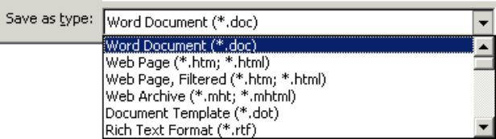
- From the File menu select Save As.
- Choose an appropriate drive and folder in which to save your file.
- In the File Name box, type a suitable filename.
- Click on the Save as type list and select an appropriate file format.
Extension | Format name | Description
.txt | Plain text | This will save the text only, without any fancy formatting or graphics.
.rtf | Rich Text Format | This saves the document in a format readable in a wide range of word processors. This is useful if you need to share a document with someone who doesn’t have access to Microsoft Word.
.htm | Web page format | This saves the document ready for publication on the World Wide Web.
.dot | Template format | This allows you to reuse the document as the basis for a new document. Templates are covered in Getting more from Word.
- Your file extension will change to reflect the file format selected from the list.
- Click Save.

Opening a existing document
- On the File menu click Open, press Ctrl+O, or click on the Open button on the toolbar:
- Choose the appropriate drive and folder.
- Select the file from the files listed e.g. mywork.doc and click on OK.
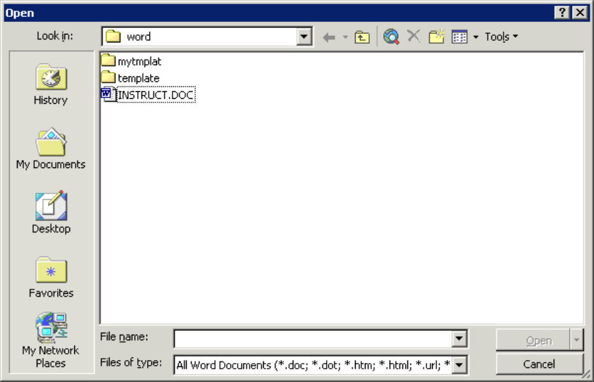
The default for Word is to open files with a .doc extension. If your document has any other extension you will need to alter the Files of type option.
Select the appropriate drive here – click on the arrow for a list.
Select the folder here – double-click on the folder icon to open it.
Any files in the current folder are displayed here.
Select the file type here – click on the arrow for a list.
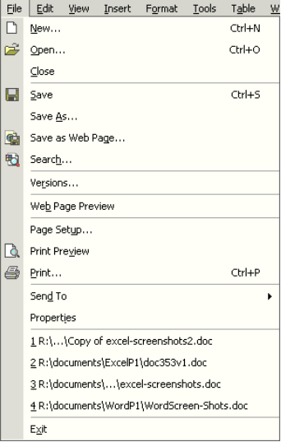
You can also open a document from the New Document task pane. Click on More documents, and follow the steps described above.
Recently Used File List (by default, 4 documents are listed.
If the document you wish to open is one of the last four documents used, you can open it directly from the File menu:
- Click on the File menu.
- Select the required file from the Recently Used File List.
Helpful hint:
The Recently Used File List does not update when you delete, move or rename files. If you try to access a deleted file from the list, an error message will appear saying that Word cannot open the document.
You can also access your most recently used files in the same way from the New Document task pane. Underneath the Open a document category, the files used most recently will be listed. Just click on the file name to open it.

Exiting Word
It is good practice to save and close your document before exiting.
- On the File menu, click on Save. Alternatively press Ctrl+S.
- On the File menu, click Exit.
Wait as Word closes down.

Switching between open documents
In Word you can have several documents open at one time. You can switch between them using the Window menu, or using the task bar. Please note that every document you have open is using resources: avoid having unnecessary files open.

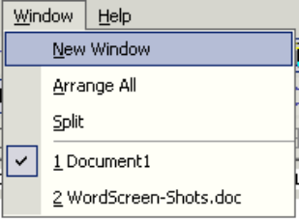
Using the Window menu
- Click on the Window menu.
- There is a list of open documents at the bottom of the Window menu.
The document currently displayed has a tick mark by its name.
- Select the required document name from the list.
- The selected document will be displayed in the active Word document area.

Using the task bar
As well as using the Window menu you can also switch between documents using the task bar. If you have more than one document open they should be listed on the task bar. Simply click on the document you wish to open.

Inserting a second document into an open document
- Open your first document and position the insertion point where you want to insert the second document.
- On the Insert menu, click File. The File dialog box is displayed.
- Select the filename of the document you want to insert.
- Click OK.
Word inserts the entire second document where you positioned the insertion point. Any text positioned after the insertion point in the original document will follow on from the end of the inserted document.

Using the help menu
There are several ways to obtain help in Word: the Word Help pane and the Ask a Question list are described here. In Microsoft Word 2003, the online help features have been embedded into the task pane on the right-hand side of the window, which allows a more intelligent and up-to-date help function.

The Word Help pane
- Use Help|Microsoft Word Help to display the Word Help pane in the task pane area as shown. Select the type of help facility you require from the Assistance, Table of Contents or Microsoft Office Online links.
- Assistance – to enter questions in the box labelled Search for. Sub-topics based on your response will be shown below. The corresponding help pages will be displayed in a pop-up window (Microsoft Office online help).
- Table of Contents – to find instructions about broad categories, organised like a book’s table of contents. As you chose top-level contents you can see a list of more detailed subtopics from which to choose. The resulting help pages display in the right of the Help window.
- Microsoft Office Online – to locate specific topics, provide online training and tutorials. You can click the links to go to the Microsoft Office Online help pages. Online training will be helpful if you want to learn the Office applications systematically. Also, the online community allows you to interact with real people, ask questions and provide answers, or take part in online discussions.
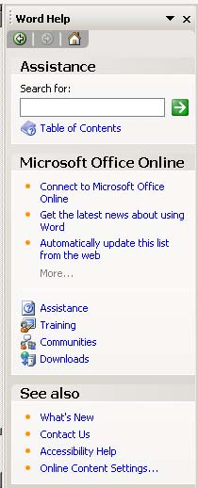
Back and Forward to move to previously viewed topics
View the table of contents

Editing a Document
Before we can make formatting changes to a document, we must first learn how to move around a document and select text.

Moving around a document
There are a number of different ways to navigate through a document:
- Using the mouse on the vertical scroll bar
- Using the keyboard
- Using the Edit menu.
Helpful hint:
The cursor can only be moved within the text area that has already been used. It cannot be moved past the end of document marker.

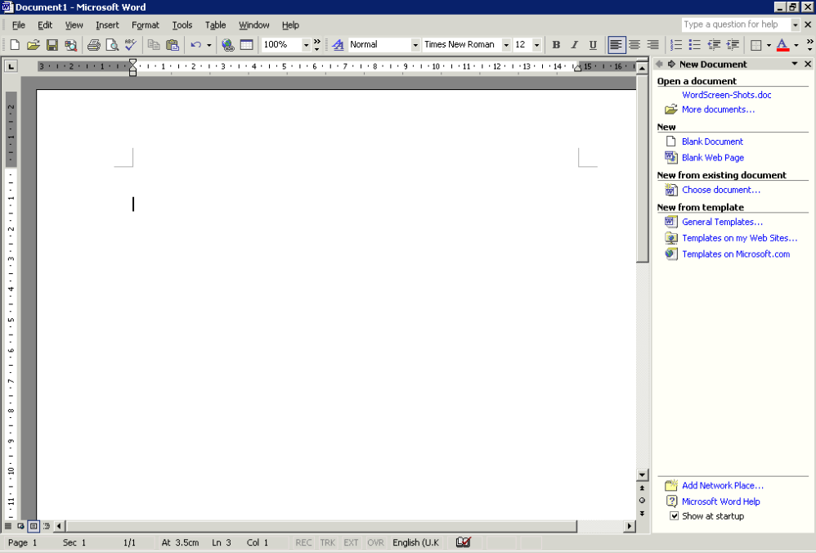
Using the mouse on the vertical scroll bar
Click the arrow to scroll upwards through the document.
Click and drag the slider up and down the vertical scroll bar to scroll through the document.
Click the arrow to scroll downwards through the document.
Click the double-headed arrow to scroll upwards/downwards one page at a time.
Use horizontal scroll bar to scroll left and ight if necessary
- Scroll up/down the document using the mouse on the vertical scroll bar.
- At the desired position, click with the left-hand mouse button in the document text to reposition the insertion point.

Using the keyboard
Arrow Keys | Movement | Ctrl + Arrow Keys | Movement
↑ | One line up | Ctrl + ← | One word left
↓ | One line down | Ctrl + → | One word right
← | One character to the left | Ctrl + End | To the end of the document
→ | One character to the right | Ctrl + Home | To the beginning of the document
Page Up | Up one screen
Page Down | Down one screen
These are just some of the keystrokes. For a complete listing, go to the Help menu, select Microsoft Word Help and then the Contents tab. There is a section called Using shortcut keys.

Using the menu
- On the Edit menu click Go To, or press Ctrl+G. The Find and Replace dialog box is displayed with the Go To tab on top:
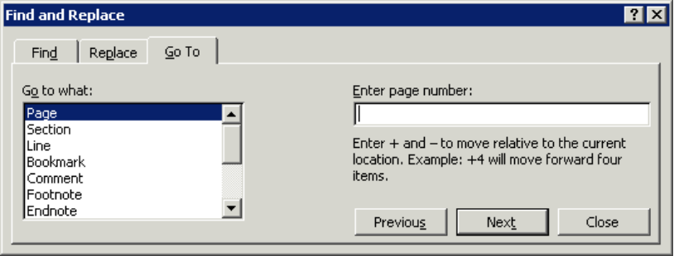
- Select an item from the Go to what list, for example, Page.
Select the item you want to go to from the list.
Enter the value for the selected item.
- Type a value in the Enter box e.g. a page number.
Helpful hint:
The name of this text box changes depending on the item selected from the Go to what list.
- Click Go To.
Alternatively, you can browse through the document by a particular item type. Having selected an item type from the Go to what list and leaving the Enter box blank, you can click Next to move to the next instance of the item or click Previous to move to the previous instance.

Selecting text
Before you can move, edit, delete, format or otherwise change any text or graphic in a document you must select (or highlight) the item first. Selected text or graphics are displayed on screen in reverse video (i.e. white text on a black background).

Selecting text with the mouse
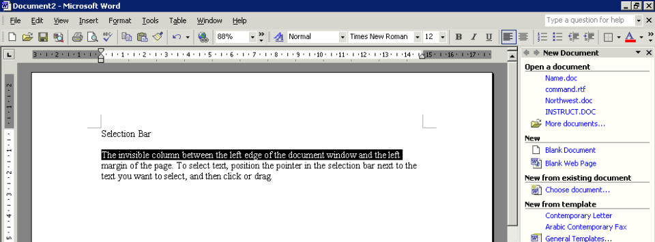
The area to the left of the text is known as the selection bar.
Selection bar
The insertion point changes to an arrow in the selection bar.

To select | Method
A single word | Double-click on the word.
A line of text | Click in the selection bar to the left of the line.
Multiple lines of text | Drag in the selection bar to the left of the lines.
A sentence | Hold down Ctrl and click anywhere in the sentence.
A paragraph | Double-click in the selection bar to the left of the paragraph or triple-click anywhere in the paragraph.
An entire document | Triple-click in the selection bar (or Ctrl+A)
Individual characters | Shift+← or Shift+→
To select non-adjacent text | Select the first piece of text then hold down the Ctrl key while you select the next bit of text, and so on. (New in Word 2003)

Click and drag method
- Position the insertion point at the start of the text.
- Click with the left-hand mouse button and drag over the area to be selected.
- Release the mouse button when you have selected the desired text.

Extended selection
If you prefer, you can select blocks of text using Extend mode as follows:
- Press F8 (EXT appears on the status bar).
- Each time you press F8 again, Word increases the amount of text in the selection – one press selects the current word, a second press, the current sentence, and so on.
- When the required amount of text has been selected, press Esc to turn off Extend mode.

Canceling a selection
Click anywhere outside the selected area.

Copying text
- Select the text to be copied.
- On the Edit menu, click Copy, press Ctrl+C or click on the Copy icon:
- Move the insertion point to the new location.
- On the Edit menu, click Paste, press Ctrl+V or click on the Paste icon:

Moving text
- Select the text to be moved.
- On the Edit menu, click Cut, or press Ctrl+X or click on the Cut icon:
- Move the insertion point to the new location.
- On the Edit menu, click Paste, or press Ctrl+V or click on the Paste icon:
Helpful hints:
It is well worth learning the keyboard shortcuts Ctrl+C (copy), Ctrl+V (paste), Ctrl+X (cut) and Ctrl+A (select all). They are indicated on the Edit menu.
You can also right-click on selected text and select Cut, Copy, or Paste from the shortcut menu.

The Clipboard task pane
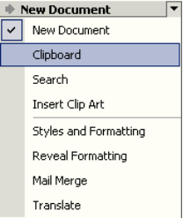
The Clipboard task pane allows you to collect lots of different items – text, graphics etc. from within Word or most Windows applications and paste them wherever you want them to go in your document. This means you can copy or cut lots of different items and store them on the Clipboard until you are ready to paste them.
Other Task Panes button

Copying or cutting multiple items
To copy or cut multiple items you need to make sure that the Microsoft Office Clipboard is displayed in the task pane. To do this, click on the Other Task Panes button next to New Document at the top of the task pane and choose Clipboard, or from the Edit menu choose Office Clipboard.
Follow the normal steps for copying or cutting text as described previously. Once you have copied the text you should see the item in the Clipboard task pane. You can copy several different items and they will appear in the task pane.
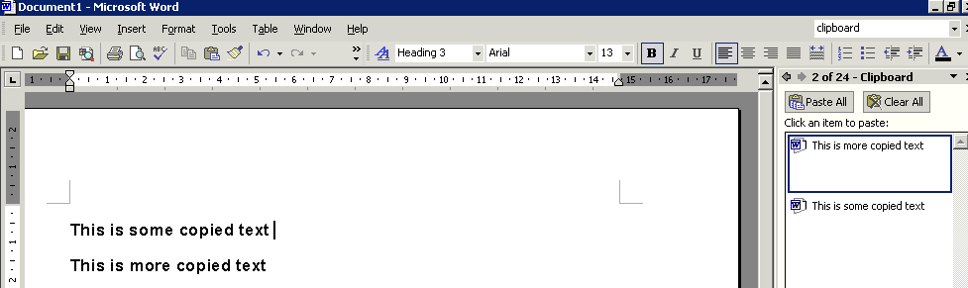
1. Select the text and choose copy.
2. You should now see the copied text in the task pane.
The Clipboard task pane will also display items that you have copied from other applications, for example, if you have copied some data from Microsoft Excel, the data will appear in the task pane, so you can copy them into Word.

Pasting and deleting collected items
To paste a single item:
- Position the insertion point where you would like the copied item to go.
- Click on the item you want to paste in the Clipboard task pane.
- The item will appear in your document.
- To paste all items from the task pane, choose Paste All.
- To delete all items from the Clipboard task pane, choose Clear All.
- To delete a single item from the task pane, select the item, click on the down-arrow and choose Delete.

Paste options
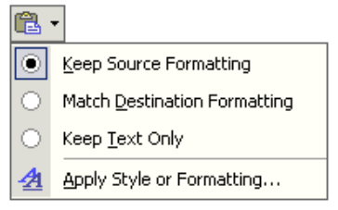
Once you have pasted the text in your document the Paste Options icon appears.
If you click on the down-arrow you will see a list of options. These options allow you to retain the formatting of the text you have copied/cut when you paste it to the new location (Keep Source Formatting). You can change the formatting of the text so that it matches the destination formatting (Match Destination Formatting) or keep the text only (Keep Text Only).

Deleting text
- Select the text to be deleted.
- Press the Delete key on your keyboard.

Overtyping text
If you want to overtype existing text rather than insert text:
- Position the insertion point where you wish to enter the replacement text.
- Double-click the OVR button on the status bar. Notice OVR becomes highlighted which means overtype mode is switched on. Alternatively, press the Insert key on the keyboard to toggle between the insert and overtype modes.
Overtype is switched on.
- Type in the new text. Notice that the new text overwrites the existing text.
When you have finished entering the text, double-click on the OVR button on the status bar. OVR will be dimmed, thereby putting you back in insert mode. Alternatively press the Insert key on the keyboard.

Undo and redo
If you make a mistake in Word, you can undo the action or command. For example, if you accidentally delete a word, you can bring it back again. If you decide to go through with the action after all, you can also redo it.
Undo
On the Edit menu, click Undo, press Ctrl+Z or click on the Undo button on the toolbar.
Word provides you with the option to undo hundreds of actions.

To undo several actions:
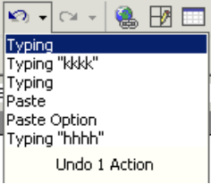
- Click on the arrow attached to the Undo icon to list your actions.
- Scroll down the Undo list and click on the action you would like to undo. This action plus all subsequent actions will be undone. It is not possible to undo a single action from the middle of the list.
Redo
The Redo facility reverses any changes that you have made with the Undo facility.
On the Edit menu, click Repeat <action>, use Ctrl+Y or click the Redo button on the toolbar.
To redo several actions:
Word provides you with the option to redo hundreds of Undo actions. Click on the arrow attached to the Redo icon to list your Undo actions.
Click on the action you would like to redo. The action plus all subsequent actions will be redone. Every step to the required action must be redone. Note that it is not possible to redo a single action from the middle of the list.

Further editing techniques

Mouse techniques for copying and moving data
In addition to the copy, move and paste methods discussed earlier, there is a drag and drop method that can speed up this common operation.

Copying data using the drag and drop method
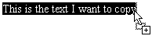
- Select the text to be copied.
- Click in the area of selected text and press the Ctrl key. Notice the mouse pointer changes shape and a small plus sign appears to indicate that the text is being copied.
- Keeping the Ctrl key pressed down; drag the text to its new position.
- Release the mouse button first followed by the Ctrl key.

Moving data using the drag and drop method
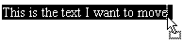
- Select the text/graphic to be copied.
- Click and drag the text to its new position. Notice the mouse pointer changes shape and there is no plus (+) sign because you are moving the text rather than copying the selected text.
- Release the mouse button.

Find and replace

Finding a word
- Position the insertion point at the start of the text.
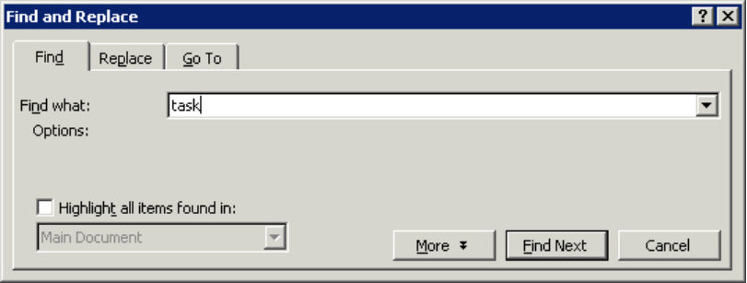
- On the Edit menu, click Find, or press Ctrl+F. The Find and Replace dialog box appears with the Find tab on top.
Enter the word you wish to find.
Click on Find Next to start the search.
- Enter the word you wish to find in the Find what box.
- Click on the Find Next button to start the search.
- Repeat step 4 until the search is complete.

Replacing a Word
- Position the insertion point at the start of the text.
- On the Edit menu, click Replace, or press Ctrl+H. The Find and Replace dialog box is displayed with the Replace tab on top:
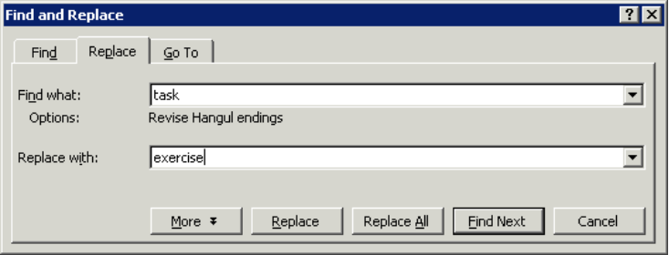
- Enter the text you wish to replace in the Find what box.
Enter the text you wish to replace.
Enter the replacement text.
Click Find Next to find the next occurrence of the word.
Click on Replace for one instance of the word or Replace All for every instance of the word in the document.
- Enter the replacement text in the Replace with text box.
- Click on the Find Next button to find the next instance of the word in the text.
- Click on the Replace button to replace this instance of the word found in the text.
- Click on the Replace All button to replace all instances of the word in the text.
- Repeat step 4 until the replacement operation is complete.

Spelling & Grammar Checking
The spelling and grammar checker checks spelling and grammar in the active document, including text in headers, footers, endnotes, and annotations.
Word contains a dictionary used to check spellings. Although the dictionary contains a very large number of words, it does not contain all possible words and spellings. The grammar-checker identifies sentences that have possible grammatical errors or a non-standard writing style. These facilities should not be relied upon entirely – there is no substitute for proof-reading a document.
Word checks your entire document, starting at the position of the insertion point. However, if you select text, Word checks only the text that you have selected.
Use the Esc key to stop the checking process.

Checking spelling and grammar as you go
Spell-checking is not automatically turned on in Word. If you would like to check your spelling and grammar as you type:
- On the Tools menu, chose Options and then select the Spelling and Grammar Tab.
- From here you need to click on Check spelling as you type and Check grammar as you type.
- Once they have been turned on, any spelling mistake will be underlined in red and grammatical errors will be underlined in green as you type.

Spell-checking a document
- On the Tools menu, click Spelling and Grammar to display the Spelling and Grammar dialog box
- Any word not found in the dictionary is displayed in red in its original sentence in the Not in Dictionary box. Where applicable, a list of alternative suggestions is shown in the Suggestions box.
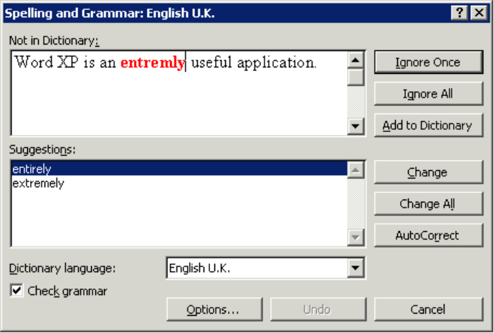
- For each word displayed in the Not in Dictionary box, click the appropriate button (for guidance, see below).
The word not found in the dictionary is displayed in red within the sentence.
Choose from the list of Suggestions.
Click Ignore Once to ignore the misspelling.
Click Change to accept the highlighted spelling in the Suggestions box.
Click Add to Dictionary to add the word to the custom dictionary.
- If none of these choices are appropriate you can manually edit a word in the Not in Dictionary box.
- You will need to click the Change button to confirm any changes.

Spelling and Grammar dialog box options
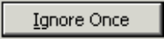 | Leave the word unchanged.
 | Leave the word unchanged throughout the document.
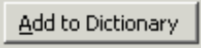 | Add the word to the custom dictionary specified.
 | Accept the spelling selected in the Suggestions box, or replace the misspelled word with the spelling you type in the Not in Dictionary box.
 | Replace all instances of the original word with the spelling selected in the Suggestions box, or the spelling you type in the Not in Dictionary box.
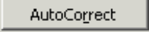 | Add the misspelled word and its correction to the AutoCorrect list.
 | Delete the second occurrence of a repeated word.

Grammar checking
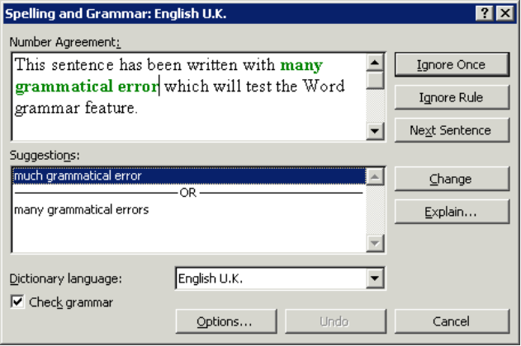
A sentence that has possible grammatical errors will be displayed in green in the Spelling and Grammar dialog box. Where applicable, a list of alternative suggestions is shown in the Suggestions box.
For each sentence displayed in the Grammar box, click the appropriate button.
 | Ignore this occurrence of the error in the sentence and continue checking.
 | Ignore the grammatical rule.
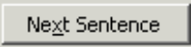 | Ignore this error and skip to the next sentence.
 | Accept the sentence selected in the Suggestions box.
When the spelling- and grammar-checking is complete, click OK to return to the document.
The following options are available in the Spelling and Grammar dialog box:
 | Cancel the spelling- and grammar-checking process.
 | Undo the previous correction. It is possible to undo all corrections made in the current spelling- and grammar-checking process in reverse order.
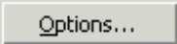 | Allows you to change spelling- and grammar-checking options.

AutoCorrect
Word’s AutoCorrect feature can be used to correct common typing errors. It can be set to capitalize the first letter of a new sentence or the names of days, correct two initial capitals, correct accidental usage of the Caps Lock key and correct common misspellings automatically. By default AutoCorrect is set so that these errors are corrected when the Spacebar or Enter is pressed after entering the text.

Creating an AutoCorrect entry
AutoCorrect can be customized to correct your own misspellings and/or to replace abbreviations with full text e.g. to replace #Hex with Corporate University.
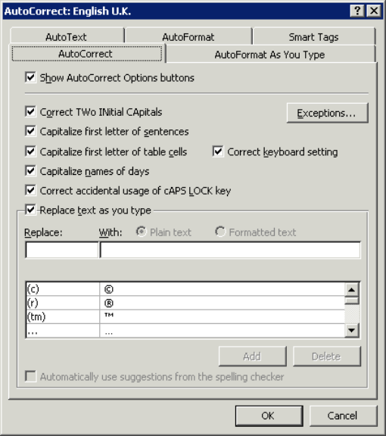
- On the Tools menu click AutoCorrect options. The AutoCorrect dialog box appears.
Click the appropriate
check boxes to select/clear options.

Type the AutoCorrect entry in the Replace box, i.e. common misspelling, abbreviation etc.

Type the replacement text in the With box.

Text box

Text box

Text box

Text box

Frequently misspelled words and their replacements are listed here.

How does Auto-Summarize work?
AutoSummarize identifies the key points in a document for you to share with others or quickly scan.

AutoSummarize works best on well-structured documents such as reports, articles, and scientific papers.

It determines key points by analyzing the document and assigning a score to each sentence. Sentences that contain words used frequently in the document are given a higher score. You then choose a percentage of the highest-scoring sentences to display in the summary.

WebCT  Version 1  June 2003

WebCT  Version 1  June 2003

for Designers

ox

WebCT

WebCT  Version 1  June 2003

WebCT  Version 1  June 2003

for Designers

ox

- Click on the AutoCorrect tab.
- In the Replace box type the AutoCorrect entry (typically this is a frequently misspelled word).
- In the With box type the replacement text.
- Click Add and then OK.

Helpful hint:
Use something unique for each AutoCorrect entry, avoiding real words or abbreviations. For example, if you put "name" in the Replace box, whenever you type this common word, Word would replace it with whatever you put in the With box..

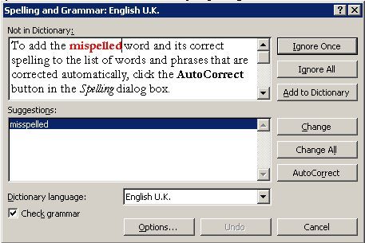
Adding an AutoCorrect entry during a spell check
AutoCorrect entries can also be added automatically during the spell-checking process.
- Click the Spelling button on the toolbar.
- When a word you often misspell or mistype is identified, select the correct spelling.
- To add the misspelled word and its correct spelling to the list of words and phrases that are corrected automatically, click the AutoCorrect button in the Spelling dialog box.

Canceling an AutoCorrect entry
AutoCorrect is configured to correct errors when the Spacebar is pressed. To cancel a correction when entering text, use the Undo button from the toolbar, or press Ctrl+Z.
Helpful hint:
You will have to repeat the Undo procedure twice if you actually intend to undo your most recent edit; the first undo only cancels AutoCorrect.

Deleting an AutoCorrect entry
- From the Tools menu click AutoCorrect.
- In the AutoCorrect list click on the entry you want to remove and click Delete and then OK.

AutoText
You can create AutoText entries to insert commonly used text or graphics e.g. your department name or the company logo.

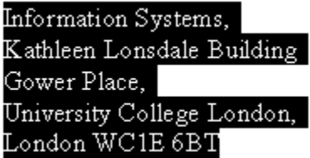Creating an AutoText entry
- Enter the text or graphics you want to store as an AutoText entry into a document and then select it.
- On the Tools menu click AutoCorrect. The AutoCorrect dialog box appears.
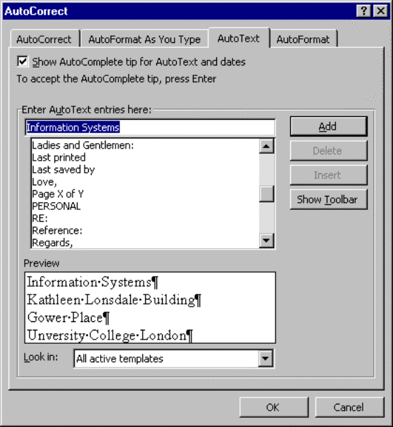
- Click on the AutoText tab. The selected text is displayed in the Preview box.
- In the Enter AutoText entries here box type in a name for the AutoText entry or accept the default.
- Click Add and then OK.

Inserting an AutoText entry
- Position the Insertion Point where you wish to insert the AutoText entry.
- Type the AutoText name and press F3.
Helpful hint:
All user-defined AutoText entries can be accessed via the Insert menu.

Removing an AutoText entry
- On the Tools menu click AutoCorrect.
The AutoCorrect dialog box will appear.
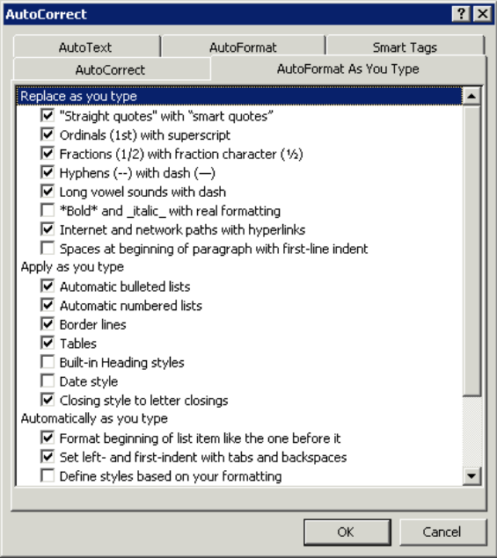
- Click on the AutoText tab.
- In the AutoText list click on the entry you want to remove.
- Click Delete and then OK.

AutoFormat
AutoFormat options provide a range of time-saving shortcuts to apply formatting such as bulleted and numbered lists, hyphens and fractions to your text. It also allows you to format Web and e-mail addresses as hyperlinks. You can automatically format a document either as you type or after you've written it. In both cases, you can control which automatic changes Word makes. You can also turn off the various automatic formatting options.

AutoFormat as you type
You can set options on the AutoFormat As You Type tab (Tools | AutoCorrect Options) to instruct Word to format text automatically as you are typing your document. An example of this is automatic bullets and numbered lists.

Undoing automatic formatting
You can click the Undo button or press Ctrl+Z to undo the action if you don’t want to accept the automatic formatting.
If you don’t want to use a particular AutoFormat option at all you should change the AutoFormat settings on the AutoFormat As You Type tab.

AutoFormat after you type
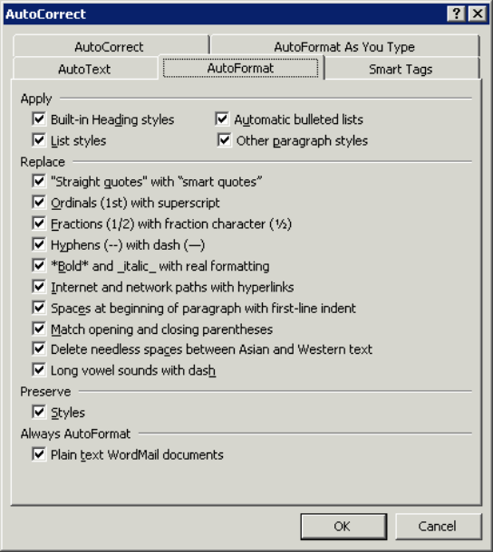
Use Format | AutoFormat to display the AutoFormat dialog box which allows you to reformat an entire document in one go. It applies formats specified on the AutoFormat tab of the AutoCorrect dialog box. Word analyses each piece of text to see how it's used— for example, as a heading or as an item in a numbered list — and then applies a style that's appropriate for that text. You can choose to do the whole document in one go, or to review each change.
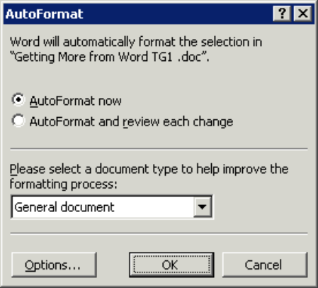
Helpful hint:
If you have already made use of styles in your document you won’t need to make use of the Built-in Heading styles option.

Viewing Modes

Different Viewing modes
There are several different viewing modes in Word: Normal, Web Layout, Print Layout, Outline and Document Map. These views control what is displayed on the screen.

Normal
In Normal view, you will see just some of the elements such as text, graphics (though these will not show their true position in relation to the page) and page breaks. This is probably the fastest view to work in, but does not show how the document will appear when printed.

Web layout
The Web Layout view optimizes the layout to make on-screen reading easier. Text appears larger and wraps to fit the window, rather than the way it would actually print.

Print layout
In Print Layout view, the page is displayed with the appropriate margins, page breaks etc., just as it will appear on the printed page. All elements are displayed in this view, so it requires more resources and may slow down the computer, especially when working with long or complex documents.

Outline
Outline view can be used for working with long and complex documents. An outline can be used to examine and work with the structure of a document. This is also a useful view when beginning a document, as it allows you to add headings easily and to reorganize the structure.

Document map
The document map displays an overview of the document by showing any headings in the left-hand part of the screen. By clicking on a topic in the document map you can instantly jump to that part of the document. The document map can be displayed alongside the other views simply by selecting Document Map on the View menu.

Changing viewing mode
Click on one of the View buttons at the bottom left of your screen.
Or, from the View menu, select from Normal, Web Layout, Print Layout, Outline or Document Map

Other viewing controls
There are two further viewing controls of which you should be aware:

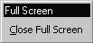
Full screen
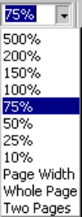
With Full Screen selected, you view just the document on screen – without rulers, toolbars, and other screen elements. This maximizes the amount of text on display. To return to the previous view, click the Close Full Screen button in the bottom-right corner of the screen.

Zoom
The zoom box on the toolbar controls how large a document appears on the screen. You can enlarge the display to make it easier to read, or reduce the display to view an entire page. You can also enter a zoom factor of your choice into the zoom box.

Printing

Print preview
Before sending a document to the printer, it is always good practice to check the appearance of the document using Print Preview. This is especially important if you usually work in Normal view.
- On the File menu, click Print Preview.
- The document is displayed in Preview, representing how the document will appear when printed.
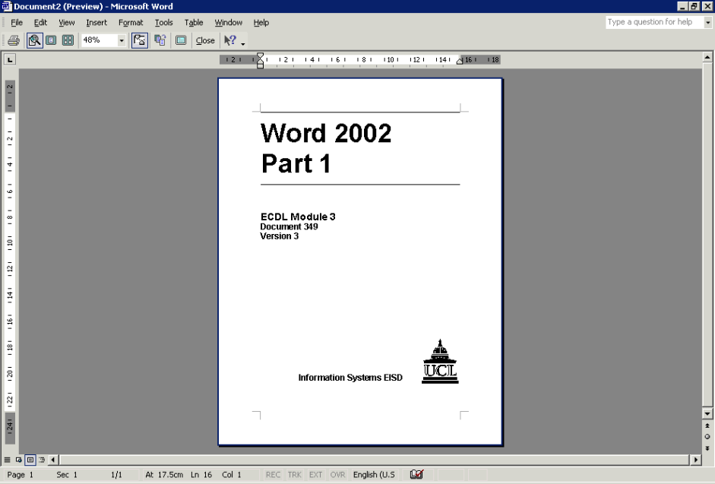
- The Print Preview toolbar appears on the screen.
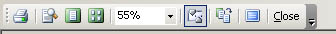
Print
Magnifier
One Page
Multiple Pages
Zoom
View Ruler
Shrink to Fit
Full Screen

- Use the Print Preview toolbar to control the magnification of the document (using the Magnifier and/or the Zoom buttons).
- Display single or multiple pages of the document (using the One Page and Multiple Page buttons).
- Choose to display or suppress the ruler in the view (using the View Ruler and/or Full Screen buttons).
- Fit the document on one page less (using the Shrink to Fit button).
- Send the document straight from the preview to the printer (using the Print button).
- Return to the previous view (using the Close button).

Printing a document
- On the File menu, click Print or press Ctrl+P. The Print dialog box appears.
Helpful hint:
Clicking on the Print button on the toolbar sends the entire document to the printer. It does not open the Print dialog box.
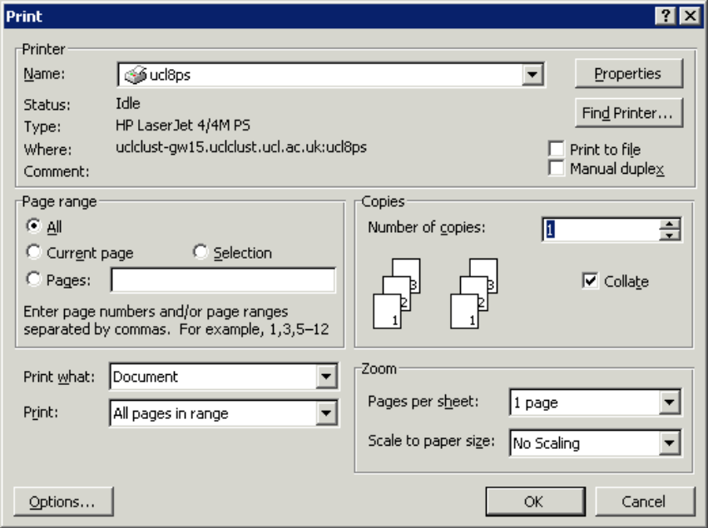
- Specify the number of copies to be printed in the Copies box.
Select the number of copies you require.
Select the part of the document that you wish to print.
- Select the Page Range: All, Current Page or enter the Pages to be printed. (Notice the format used e.g. 1-5 will print pages one to five inclusive; 1,3,5 will print pages one, three and five).
- When you have completed your selections, click on OK.

